Doug Marcum

DSC 640 – Project Task 3 – Blog Post

This is a backup copy of the blog post. The post can be accessed at [**https://dsc640-doug-marcum.blogspot.com/**](https://dsc640-doug-marcum.blogspot.com/).

**Flying the Friendly Skies**

*Is it still safe to travel by air? Should my family be flying to Florida for Spring Break this year or driving? Should our sales reps be flying or driving to visit clients around the country?* Due to a recent unfortunate airline incident, many travelers are asking these and other questions when making decisions on how they will be getting to their destination. With an increase in media coverage pertaining to the safety of air travel and several opinions being shared on the topic, it is a valid concern to take into consideration.

Our team of researchers and data scientists have tackled the topic and reviewed multiple data sources to assess the current situation. With a focus placed on the period of 2000 to present, we have been able to determine if air travel is still the safest way to travel.

**Air Travel Growth**

To put the safety findings into context, first we must look at the record number of passengers embarking on air travel. Since 2000, the annual number of air travelers has increased from 1.7 billion to 4.3 billion globally. **This is a massive increase in air travel, 143%, in less than 20 years.** This, in conjunction with cargo planes, equates to approximately 3 million monthly flights occurring around the globe. Below is a snapshot of 13,000 mid-air flights at 12:30 pm Eastern on July 12, 2020 via flightradar24.com.

[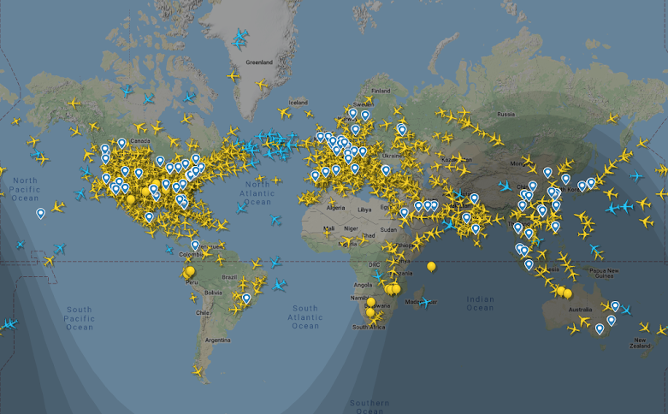](https://www.blogger.com/)

**Safety**

One would assume that with such an increase in the number of daily flights, that fatal accidents would surely increase. Luckily, this is a false assumption as the findings state quite the contrary. Since 2000, the number of fatalities related to air travel has been on a steady downward trend. This can be seen in the data provided by the Bureau of Aircraft Accident Archives and illustrated below.

[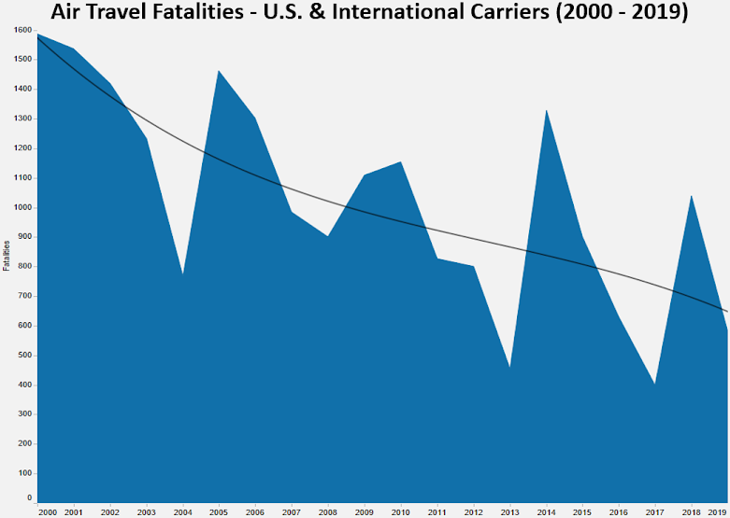](https://www.blogger.com/)

Additionally, U.S. Carriers have an outstanding safety record over the past decade. **Total reported accidents by U.S. Carriers has not exceeded 29 in any year since 2005 and only two fatal accidents have occurred since 2009.**

[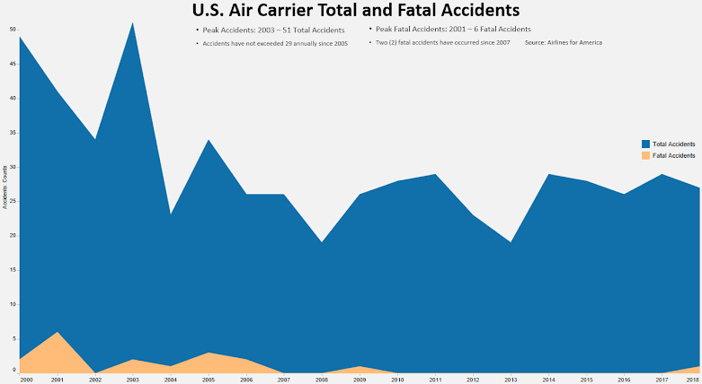](https://www.blogger.com/)

These number reinforce the fact that air travel continues to be an extremely safe form of transportation but can still be a bit difficult to put into perspective. Many Americans travel via automobile daily. The car is as American as apple pie, but much more dangerous. Over the past 10 years, the United States has averaged **31,779 fatal automobile related accidents annually**. During this same period, U.S. airlines have been involved in **2 fatal accidents**. This alone highlights the overall safety of traveling by air, in comparison to a motor vehicle.

[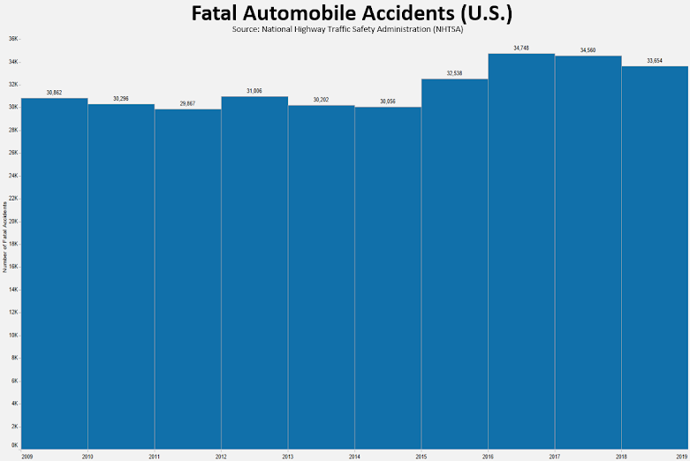](https://www.blogger.com/)

**Conclusion**

Unfortunately, when an air related accident occurs, the result can have a far greater impact on us mentally than what occurs physically. Often, the accident reaches into multiple communities and the accident itself can produce graphic violent imagery. Fortunately, the air industry continues to focus on the safety of all passengers. The joint effort of industry leaders, air traffic controllers, pilots, and maintenance engineers create an army of professionals focused on a pleasurable, safe experience for all passengers. By doing so, air travel continues to be robust, with a growing number of passengers traveling for business, as well as pleasure. Annual global air passengers have increased 143% since 2000 and over 59% since 2010, and over 4.3 billion global passengers traveled by air in 2018 alone. All of this while the number of annual accidents and fatal accident has decreased. This coordinated effort continues to provide a superior means of safe travel, when compared to auto related travel. Through unrelenting commitment to investments in safety and technology, the air industry is poised to continue being a leader in safe travel.

**Sources**

[Airline Safety](https://www.blogger.com/), Aviation Safety Network

[Death Rate Per Year](https://www.blogger.com/), Bureau of Aircraft Accident Archives

[Safety Record of U.S. Air Carriers](https://www.blogger.com/), Airlines for America

[World Airlines Traffic and Capacity](https://www.blogger.com/), Airlines for America

[Fatality and Injury Reporting System Tool (FIRST),](https://www.blogger.com/) National Highway Traffic Safety Administration (NHTSA)